**DAILY ONLINE ACTIVITIES SUMMARY**

|  |  |  |  |  |  |  |  |  |
| --- | --- | --- | --- | --- | --- | --- | --- | --- |
| **Date:** | **06/07/2020** | | | | | **Name:** | **SUJANA** | |
| **Sem & Sec** | **IV sem & B section** | | | | | **USN:** | **4AL18CS089** | |
| **Online Test Summary** | | | | | | | | |
| **Subject** | | **Complex Analysis, Probability and Statistical Methods** | | | | | | |
| **Max. Marks** | | **30** | | **Score** | | | **-** | |
| **Certification Course Summary** | | | | | | | | |
| **Course** | **Predictive Modelling and Analytics** | | | | | | | |
| **Certificate Provider** | | | **Greatlearning academy** | | **Duration** | | | **5.5 hours** |
| **Coding Challenges** | | | | | | | | |
| **Problem Statement1:**  Write a Java program to find the Nth natural number with exactly two bits set | | | | | | | | |
| **Status: Executed** | | | | | | | | |
| **Uploaded the report in Github** | | | | | **YES** | | | |
| **If yes Repository name** | | | | | **Online-coding** | | | |
| **Uploaded the report in slack** | | | | | **YES** | | | |

**Online Test Summary: Today 18MAT41 Descriptive test was conducted there were three questions the test was from 9:30am to 10:15am.Scores not received.**

**Online Certification Course Summary: In today’s session I have learnt about Multiple linear regression in predictive modelling and analytics.**

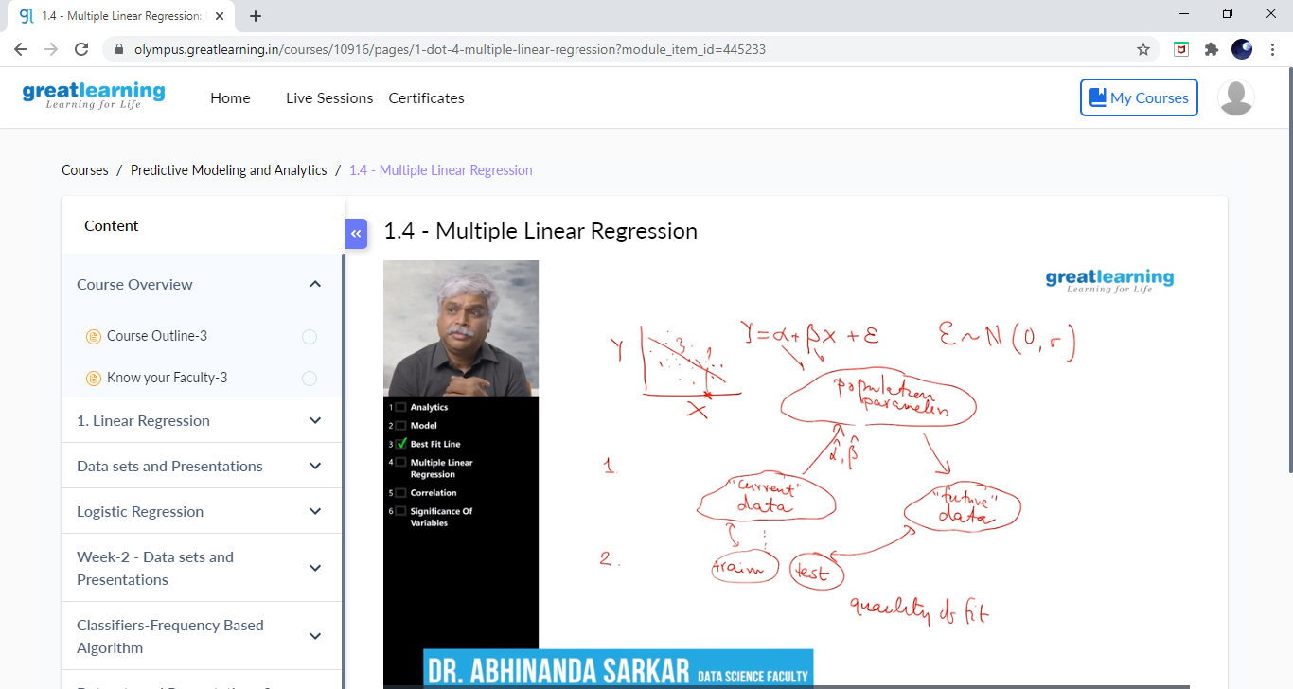

**This is the snapshot of today’s session.**

**Online Coding Summary: Today I had received one program from prof. Shilpa CSE Dept. The program is mentioned above in the coding challenges. I have also uploaded it to my Github repository.**

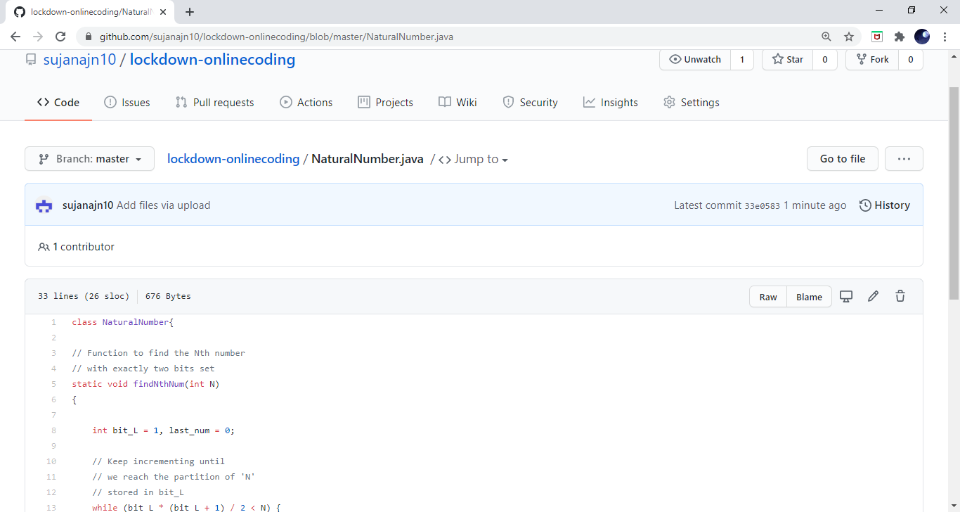**This is the Snapshot of my Github repository** were I have uploaded the code. File name is NaturalNumber.java